**Spin Check**



Robby Peery, Zev McMillen, Blake Widlund, Zac Chan

December 9, 2021

INFO 4700

Github Link: <https://github.com/robpeery/SeniorCapstone>

Website Link: <https://zaccha.github.io/SpinCheck/SpinCheck>

**Spin Check**

Cheating has always been a very polarizing issue in the world of professional sports. A scandal of some sort has seemed to arise in almost every major sports league, however, other than professional cycling ([NY Times](https://www.nytimes.com/2020/01/17/learning/sports-cheaters-punishment.html)), Major League Baseball (MLB) seems to be plagued by cheaters far more than any major professional sports organization. Not only that, but it seems as if players and managers have developed a culture of cheating within the past thirty years. Whether it’s stealing team secrets ([NY Times](https://www.nytimes.com/article/astros-cheating.html)), corking up bats ([Youtube](https://www.youtube.com/watch?v=Ft-pWVaRnQ8)), or taking steroids ([The Ringer](https://www.theringer.com/mlb/2018/9/28/17913536/mark-mcgwire-sammy-sosa-steroid-era-home-run-chase)), it almost feels like MLB’s teams and players move from one cheating tactic to another. Every evolution in the cheating culture around baseball has been an obvious complex situation for the executives at MLB. When cheating occurs at the highest level, it can affect not only teams, the league and players, but the sport of baseball as a whole.

Professional athletes have gotten caught cheating in every major professional sports league at some point. Punishments for their actions come in all shapes and sizes too, ranging from small fines from the leagues to entire FBI investigations. From a casual perspective it might be easy to say, “Cheating is bad, but should the FBI really be getting involved and spending time on these scandals?” ([FBI](https://archives.fbi.gov/archives/washingtondc/press-releases/2010/wfo081910.htm)) It is important to realize, due to the fact that professional sports are so modernly commercialized, there are many different stakeholders involved in the outcomes of games/events. The best related example is the story of Lance Armstrong. The situation involving Lance is obviously complicated for many reasons, but it can’t be disputed that illegal doping played a role in his seven Tour de France victories. But what was the result of that lie outside of cycling? Lance was a national hero to many, which also propelled the Livestrong Foundation to the public eye, which has now served over 9.4 million cancer patients. ([Livestrong](https://www.livestrong.org/who-we-are/our-history#beginning)) It is evident the reach and implications of Lance’s cheating extended far beyond cycling in ways that could never be considered at the time. In this instance, the unforeseen reach of Lance’s cheating had a positive effect on many, but that is not the case most of the time.

The same rules obviously apply to baseball and MLB. Barry Bonds is one of the biggest names in the history of the league because he was cheating. Nobody realized it at the time, however, he was one of the biggest names in sports. Cheaters have always succeeded in baseball more than they have failed, which has created a culture of teams bending the rules to gain any advantage possible.

In order to understand the history and culture of cheating surrounding MLB, it is important to understand what is regarded as the “steroid era.” The “era,” which is roughly defined from the late 80’s through late 2000’s, “refers to a period of time in Major League Baseball when a number of players were believed to have used performance-enhancing drugs, resulting in increased offensive output throughout the game.” ([ESPN](https://www.espn.com/mlb/topics/_/page/the-steroids-era)) Hundreds of players were believed to be using banned anabolic steroids in order to gain advantage on the field. To put into perspective how widespread steroid use was in the league, “Of the 13 players who hit 40 or more home runs in 1998, eight have now been linked, through Major League Baseball testing, the Mitchell report or other sources, to use of such drugs” ([New York Times](https://www.nytimes.com/2009/07/05/sports/baseball/05homers.html)).

Although steroid use created an unfair playing field across the league, a direct result of the practice was an offensive spike never seen before in MLB. While looking at hitting numbers, it is not hard to find significant increases in both standard and advanced statistics during the steroid era. Just looking at standard home run statistics in figure[1], it is evident that offensive production ramped up during the 90’s. Teams across the league hit an average of 118.1 home runs in 1994, only six years later, the average home run count was 189.8. While it’s always important to consider other possible factors that contributed to the increase in hitting, it is widely accepted that the 60% increase in home runs is attributed to widespread anabolic steroid use.

**(Fig 1)** ([Interactive Version](https://public.tableau.com/app/profile/rob.peery/viz/AverageTotalTeamHomerunsaSeason/Dashboard1?publish=yes))

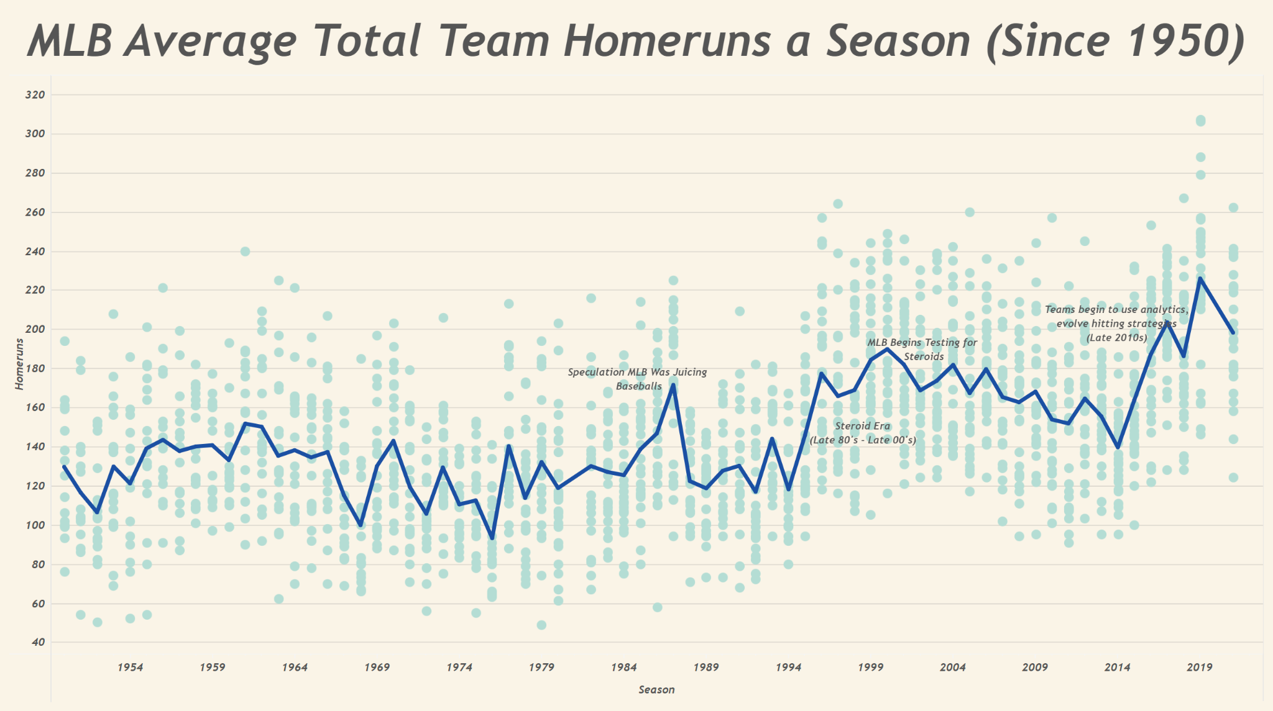

Standard statistics often don’t tell the entire story in baseball. It is important to also look at a more advanced metric such as Weighted on Base Average (wOBA). “wOBA is a rate statistic which attempts to credit a hitter for the value of each outcome (single, double , etc) rather than treating all hits or times on base equally. Weights change slightly with the run environment, but the current general formula can be found here: [Fangraphs](https://library.fangraphs.com/offense/woba/). Basically, wOBA is a measurement of the rate of a quality hit. The higher the wOBA, the more the team is getting extra base hits (doubles, triples, home runs). For context, an excellent individual wOBA is considered to be over .40, whereas a poor one is considered to be under .30. When analyzing team wOBA over the same period as home runs, a similar pattern is evident. wOBA also demonstrates a rise throughout the 90’s, finally topping out in the year 2000. However, wOBA hasn’t seen a dramatic rise in the last ten years unlike home runs. It is interesting to see the discrepancy, as home runs are a large contributor to wOBA. When looking at average wOBA as displayed in figure[2], it can be inferred that despite more home runs being hit, hitters don’t seem to have as big of an advantage as they did throughout the 90’s.

**(Fig 2)** ([Interactive Version](https://public.tableau.com/app/profile/rob.peery/viz/AverageTeamwOBA/Dashboard1?publish=yes))

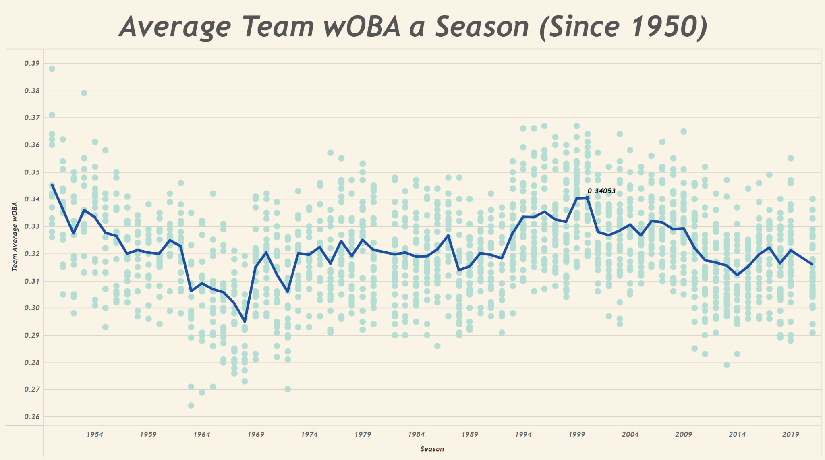

Although HR’s and wOBA are two distinct statistical methods, many offensive statistics tell a similar story. Anabolic steroids undoubtedly had an effect on the offensive production throughout the MLB. Abuse was an obvious problem for the integrity and ethics of the game, but the league also benefited greatly. The greater offensive production created a more exciting product for fans as a result. With more action than ever before, MLB gained more and more attention in the professional sports landscape ([SportsNaut](https://sportsnaut.com/mlb-ratings-tv-viewership-numbers/)). Today, MLB is constantly searching for ways to engage fans, and it can be argued the highest fan engagement the league had ever seen was during the Steroid era. MLB has a responsibility to ensure every team is on an even playing field, but if their responsibility was to shift to purely entertainment for fans, the league would most likely allow anabolic steroids immediately. “The steroid era” is evidence that cheating has made baseball more exciting.

It is important to also understand, only a couple years ago (2019), MLB had to handle a massive scandal revolving around the World Series Champion Houston Astros. The scandal this time revolved around the team stealing pitching signs from their opponents using cameras. The scandal itself, as well as the discourse around it, was a big deal for the league. Not only because the Astros happened to win the World Series the year they were caught, but it also added another cheating scandal to a long list for MLB. As the world started to research what exactly acts of cheating the Astros were performing, it turns out that the first place to look was the analytics comparing their Batting Average (BA) and home run total. Researchers began to see noticeable differences in batters performance compared to the years prior to the scandal. Players that were usually swinging at balls at a higher rate were now more patient and waiting for the right moment to hit. It became aware to the public and those involved in Major League Baseball that the Astros players knew exactly when to hit the ball with pitches that favored the batter. As the analytics began to show “red flags,” others started to pay close attention to how they were signaling their batters. It was eventually found that teammates would “bang” on trash cans to signal what pitch was coming. Major League Baseball (MLB) became aware of these actions years after the World Series win and decided on the punishment. It included draft picks in 2020 and 2021 drafts would be taken and a fine would be placed on the team. There were a few suspensions among the coaches for the entire 2020 season. In all, the Houston Astros were able to get away with cheating and keep their championship banner hanging. Major League Baseball decided this punishment and the fans/organizations responded. With little to no punishment, it became apparent that teams can cheat and get away with it. Which brings the research to the sticky substance scandal the MLB faces now.

This year, MLB took on a league-wide cheating scandal involving many pitchers dousing their hands in illegal sticky substances in order to gain an advantage. With a stickier hand, a pitcher is able to get as much grip as possible on the ball, thus allowing him to spin it at a higher rate. Typically an MLB pitcher’s spin rate or RPM (Revolutions per minute) range between 1800 RPM to 2600 RPM with a lower and or higher RPM being vastly more effective than those that ride the line in the middle. Sticky substances allow for pitchers to gain more control of their desired spin rate. If the pitcher desires a lower spin rate on a fastball the ball will fall faster. Inversely, if the pitcher has a high RPM fastball the ball will appear to rise, and is more difficult for the batter to square up on the pitch. Ultimately, gaining more control of the baseball’s spin equates to the pitcher being more effective on the mound and making their pitcher more unpredictable for the opposing batter.

The timeline for when this practice became league-wide is foggy, however it started becoming a topic of discussion among players and fans during the 2019 season. ([The Ringer](https://www.theringer.com/mlb/2021/6/16/22536140/foreign-substances-crackdown-memo-pitchers)) For this reason, this specific cheating scandal was somewhat expected, as it was common knowledge among most players in the league that most pitchers had begun dousing up their hands. But, the league seemingly decided to turn a blind for at least a season, as 2020 Cy Young ([MLB](https://www.mlb.com/news/trevor-bauer-wins-2020-nl-cy-young-award)) winner Trevor Bauer openly used foriegn substance on his hands.

However, during the 2021 season, the discourse around illegal sticky substances became more and more of a story around baseball, and suddenly the league had another issue with cheating on their hands. For many reasons it was incredibly complicated for the league to navigate, but a rule change was finally implemented mid 2021 season in order to crack down on the illegal sticky substances. Although MLB seemingly wants to put the entire thing in the rearview mirror, there are still many questions that remain around foriegn sticky substances and MLB’s enforcement of them. Was the advantage significant enough to even warrant a ban? How have individual pitchers adapted since the ban? How have batters been affected by illegal sticky substances? The league, players, teams, and fans are all looking for more answers regarding just how this specific fad of pitchers breaking the rules affected baseball. Thankfully, MLB collects an intricate amount of data for every game. By sifting through and visualizing different aspects of MLB data, more insight can be drawn on not only whether or not foriegn sticky substances had an effect on MLB, but also how it changed how the game of baseball is played as a whole.

Baseball has been a sport statheads have always gravitated to, the stories baseball statistics can tell have always been an exciting part of the spectacle and storylines in MLB. But, the vast landscape of data MLB offers can easily be overwhelming and confusing to casual fans. On top of that, the addition of Statcast, (which the league refers to as, “A state-of-the-art tracking technology that allows for the collection and analysis of a massive amount of baseball data, in ways that were never possible in the past” ([MLB](https://www.mlb.com/glossary/statcast)) takes overwhelming baseball statistics to a whole new level. However, once the state of the art technology was implemented in 2015, players, teams, and fans have been able to look at the game in a whole different perspective. As a result, it has opened the door for entirely new analytics based strategies revolving around statcast analysis. Evidence of more data analysis in the baseball community can be seen from data analysis worksheets that are regularly uploaded to github, reddit, and from major sports journalists. Furthermore, this is why the evidence that sticky substances were increasing a pitchers ability to perform on the field was found by sifting through spin rate or baseball RPM data. Ultimately, the statcast data infrastructures allow for more profound data to be tracked and visualized to enable numerous perspectives of baseball to be revealed to the masses.

For data collection, we used an open source Python Library called PyBaseball to access the MLB API. Doing this, we were able to access almost every standard and advanced statistic within the MLB API. We then used Jupyter Notebooks to filter and clean specific data, and finally, downloaded that data to Tableau in order to visualize it.

So did the ban have an impact on pitchers? There are almost an infinite number of aspects to look at for insight, but the simplest place to start is looking at average spin rate from across the league. To make figure[3] below, we took spin rate data from every fastball thrown over the course of the 2019 and 2021 season. Then, we averaged the fastball spin rates by day over the course of each season. Due to the fact there are a varying number of games and different pitchers

**(Fig 3) (**[Interactive Link](https://public.tableau.com/app/profile/rob.peery/viz/spinrateviz/Dashboard1?publish=yes)**)**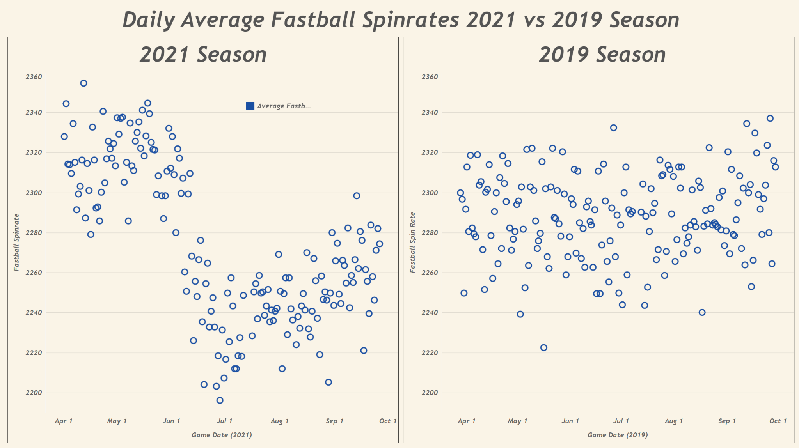

each day, this method isn’t the best way to get a completely accurate representation on average.

fastball spin rate across the league. However, it provides preliminary insight to how drastically the league ban of sticky substance affected fastball spin rate. As figure[3] shows, there is really nothing significant in 2019 spin rate trends. It is a very different story for the 2021 season, as there is a very noticeable dropoff in average spin rate right around when the league began discussing enforcement options. From this information it can be confirmed that pitchers were significantly altering the way they pitched using sticky substances. It is also interesting to note the slight rise in spin rate towards the end of the 2021 season. Looking at this specific data, it can be seen that pitchers took a little bit of time to adjust to the new rules, but now spin rates are rising once again. From here, we can examine further how the drop in spin rate affected other pitching statistics, as well as how it varied between individual pitchers.

ERA is an integral standard measurement of identifying a pitcher’s game or season performance and their effectiveness to defend against runs. There are varying factors for how an ERA is affected from the pitcher’s mental health, health, crowd, weather condition, altitude, and many more. However, spin rate is also a factor which affects a pitcher’s ERA because pre and post ban there was a significant reduction in a pitcher’s K% (strikeout percentage). This is the percentage of batters that the pitcher strikes out, indicating they did not receive a hit, fly out, or infield related out. This metric is solely on the performance of the pitcher throwing a baseball past the strike zone without the batter making contact with the ball. Anthony Castrovince, from MLB news reported, “We saw the lowest strikeout rate (22.5%) and the lowest walk rate (8.2%) of any week of the season (first week of the sticky substances ban) ([MLB](https://www.mlb.com/news/faq-sticky-stuff-and-new-rule-enforcement)). As the strikeout rate continues to fall this will inevitably affect a pitcher and team’s ERA.

From our data analysis of pitcher ERA’s pre and post the sticky substances ban we concluded that it had little to no effect on a total teams ERA (collection average of the pitchers bullpen). A supplementary source of this ERA distribution was posted on [Reddit](https://www.reddit.com/r/baseball/comments/pkgwbr/team_era_pre_and_poststicky_ban/). In this dataframe we can see that ERA differentials from pre and post ban varied slightly however not enough to argue that banning sticky substances genuinely effected MLB ERA. The highest negative differential was from the Atlanta Braves who’s ERA decreased by -.84. However, again, this is not a distinct relationship with the ban of sticky substances. Some teams defensively performed poorly towards the end of the season due to injury, trades, and so on. Moreover, understanding how ERA is composed illuminates statistical categories that would be more directly related to the sticky substances ban, such as strikeout rate.

To put in context how different pitchers adapted to the new rules, we can dive deeper into individual stats of certain pitchers who’s spin rates drastically changed during the season. While referring to figure[4] below, one of the most glaring data points on the scatter plot shows Yusei Kikuchi’s changeup. Not only did the spin rate drop drastically, Kikuchi’s WHIP (Walks and Hits per Inning Pitched) got substantially worse as well. Kikuchi is an extreme example of a player performing worse as a result of the ban, but a similar and less extreme story is shown for a majority of pitchers. One of the most prevalent pitchers, and interesting cases is New York Yankees ace Gerrit Cole. Before June 20th, Cole was a clear cut favorite to take home the AL Cy Young award. His standard statistics were some of the best in the league before the ban. Opponents against Cole had a .188 OBP and a .177 wOBA against Cole in the first half of the season. Comparing that to his statistics after the substance ban, Cole put up a .301 OBP and a wOBA of .307. For context, a .188 OBP for a pitcher is among the league’s best, whereas .301 is about on par for league average. Looking at Cole’s spin rate on top of his standard statistics, it is evident that the sticky substance ban had a negative impact on Cole in one way or another. While a majority of pitchers' average spin rate fell after 6/20, it wasn’t always the case that they performed worse. A really interesting case that shows up in the data is Madison Bumgarner of the Arizona Diamondbacks. Bumgarner’s spin rates drastically fell just as much as any pitcher in the league, however, he actually performed substantially better in the 2nd half of the regular season. Bumgarnder saw almost all of his standard statistics improve after the league ban. Definitely an anomaly, but Bumgarner demonstrates that spin rate isn’t always linked to performance.

**(Fig 4)** ([Interactive Link](https://public.tableau.com/app/profile/rob.peery/viz/PitchTypeDifferences/Dashboard1)**)**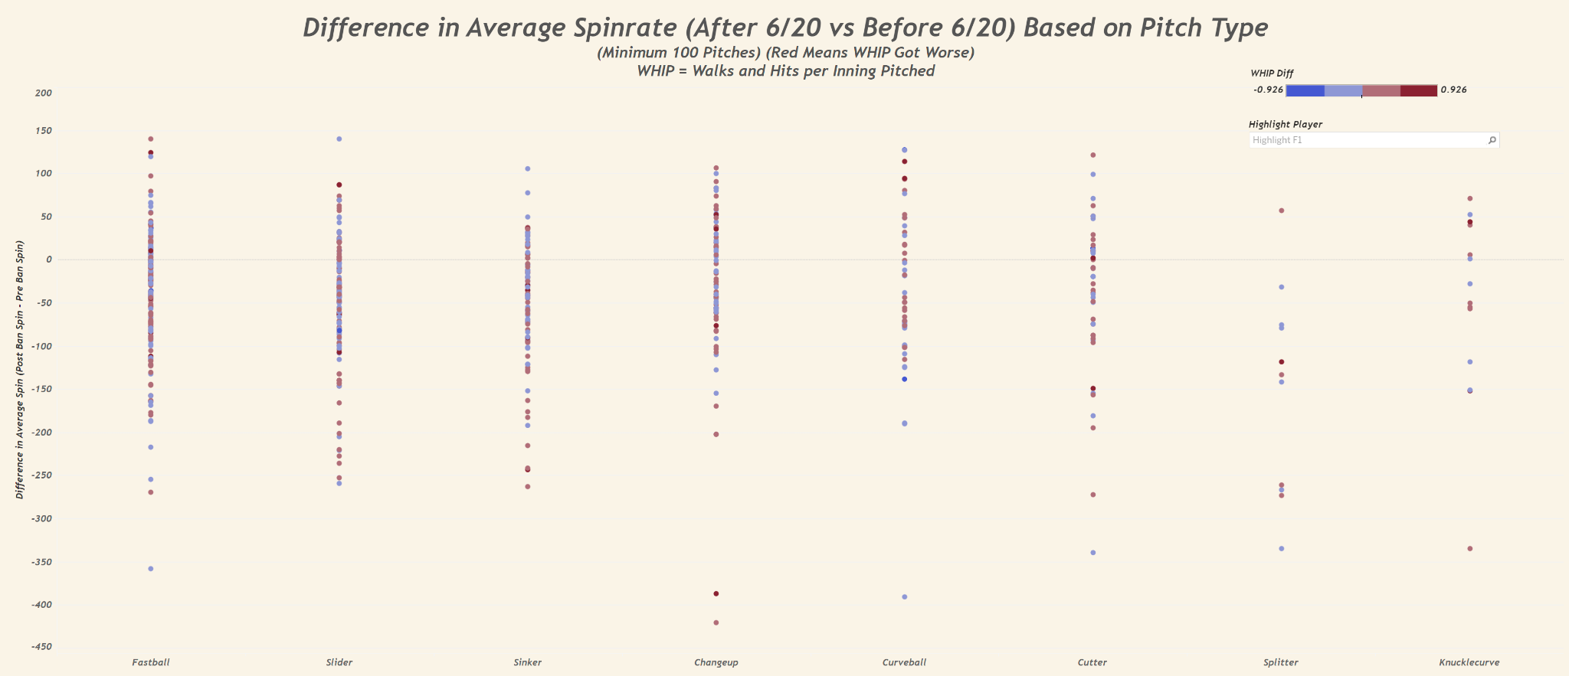

Pitchers obviously were not the only players affected by the midseason rule change. Hitters statistics also saw a significant change as a result of the ban as well. Batting average.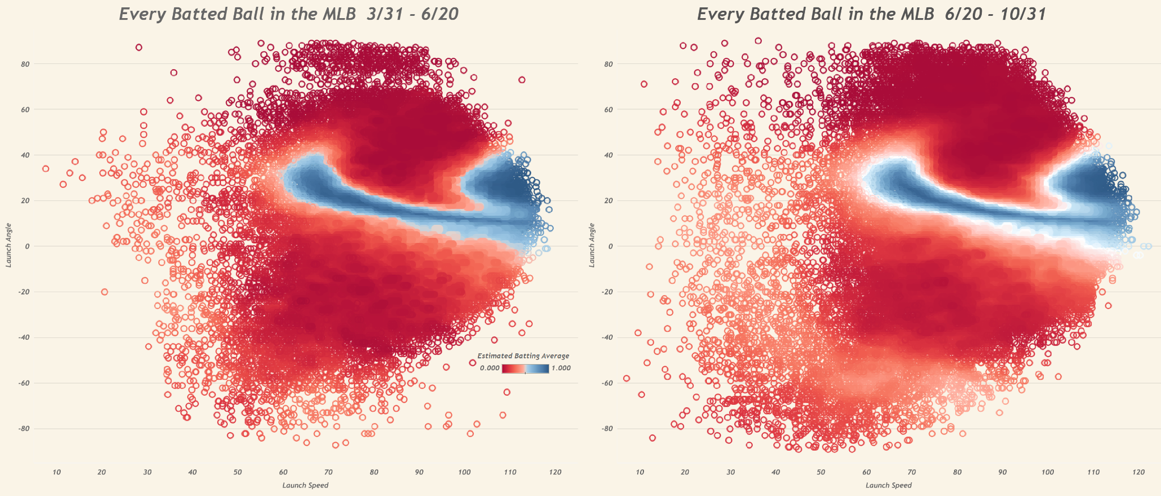

**(Fig 5)** ([Interactive Link](https://public.tableau.com/app/profile/rob.peery/viz/BattedBallStats/Dashboard1))

across the league saw a jump from .235 before the ban to .248 after the ban. To visualize this change, in figure[5] we plotted every batted ball in the league before and after the ban to see if there were any glaring anomalies. What we found was that before the ban, based on estimated batting average ([MLB](https://www.mlb.com/glossary/statcast/expected-batting-average)) a majority of batted balls were either a very low or high xBA. Comparing that to after the ban, were a lot more 50/50 batted balls according to the scatterplots. This tells us that hitters gained an advantage as a result of the ban, which isn’t surprising judging from the league wide decrease in spin rate.

Indicating whether a player or not was cheating has some ethical ramifications above having the data fit a specific narrative. There are also numerous causal factors that could skew the information of whether a pitcher, or any player for that matter, is cheating. Therefore, we focused on group aggregation of pitchers and normalized variance distributions to illustrate indicators of cheating. For example, imagine you are teaching an university accredited course and after the first exame you have a hunch that your students may be cheating. To investigate you find the standard deviation and variance between their deviations to identify how the class clusters. If their independent variances are clustered it is reasonable to assume that the class is cheating. However, if their variance distribution range is wide, points are farther apart, we can assume they are not cheating. We applied this same ideology with pitching spin rates and strikeout percentage with a 95% confidence interval.

In figure[6] below this is the pitching strikeout rate across pitchers that played both before and after the ban. The blue colored lines are the variance distribution of players after the ban. Conversely the orange lines are the variance distributions of players who pitched before the ban. Initially we can identify that the range in their respective distributions are visibly different. Mainly, that the variance range between players become less clustered after the ban. We can reasonably assume that from this visualization that players were in fact using some substance or outside factor to improve their normalized distribution of strikeout rate. Ultimately, the range of player variances increasing after the band gives substantial mathematical evidence that pitchers were cheating with sticky substances. Moreover, because the variance increase is shown across all players sampled we can assume that the majority if not all pitchers were utilizing some sort of substance to alter their performance collectively.

**(Fig 6)** 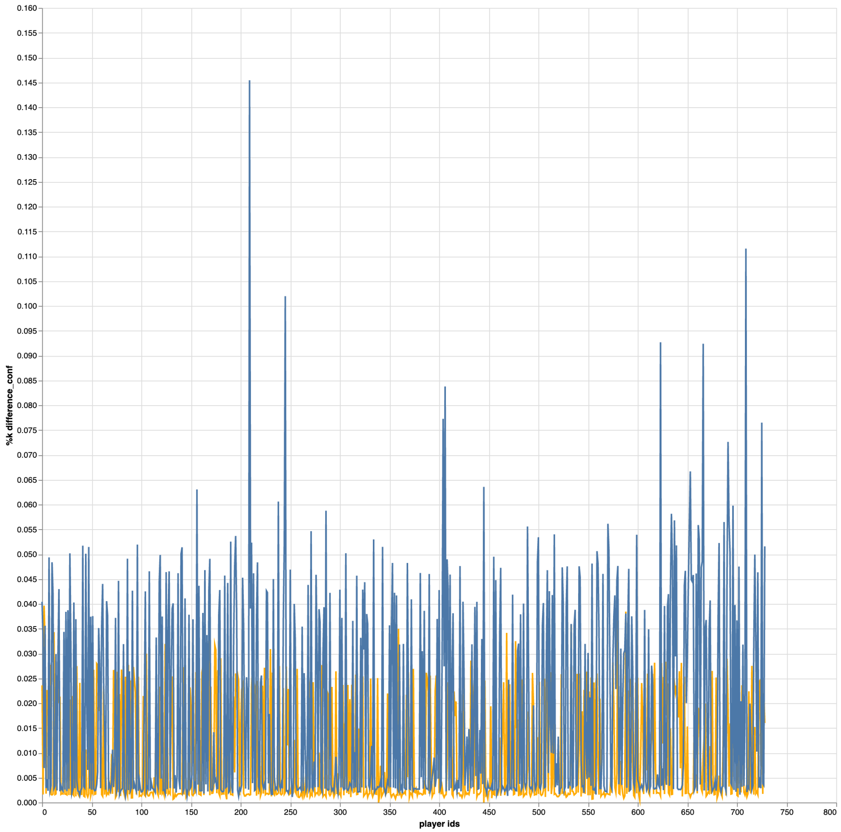

Similarly, we analyzed the same variance distribution for pitching spin rates as seen in figure[7]. We found similar results. The variance between pitcher spin rate before and after the ban increased dramatically. Further indicating that a communal substance was being used by the league before the ban was in place. The drastic increase in the variance, overall, indicates that the majority of the league were using the banned sticky substance.

**(Fig 7)**

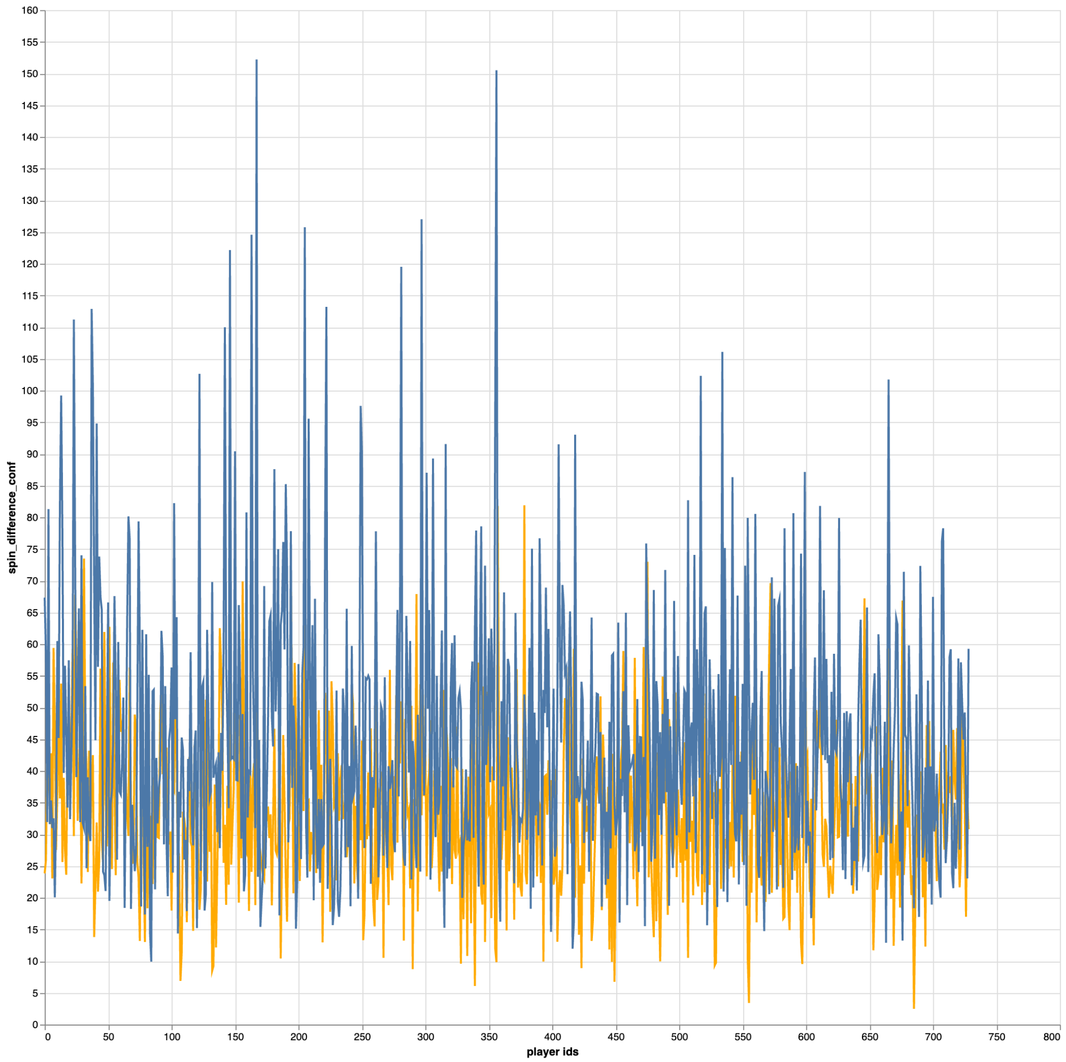

One key understanding with our research in pitchers variance distribution was that there is room for underlying bias. For scale, the pitching sample studied were pitchers that had at least one inning pitched before and after the ban. Of those pitchers, we studied their ‘career’ statistics; which are randomly sampled from their individual game statistics to create a year and then ‘career’ statline before and after the ban. Because the sample between the two data sets had varying numbers of instances the player data after the ban may not conclusively indicate their true variance distribution. In an effort for ethical data science, more work needs to be accomplished to conclude if the majority of the league was cheating by using the illegal substance before the official ban. Future work that could improve our metrics includes future statistical measures of both spin rate and strikeout rate within the same player ID categories will improve the legitimacy of our variance distributions. Furthermore, we would expect that the distribution clusters become more closely related and as they become further normalized. However, we also believe that the visual line between the distributions will still be recognizable and indicate pitchers using illegal substances.

It is evident through multiple avenues of data that there was widespread sticky substance abuse across the league. The drastic dip in average spin rate, the increase in hitting production, and pitchers variance distribution are just some of the examples of evidence. However, a question that still eludes the data in this context, is use of sticky substances considered cheating in this instance? If a pitcher was using sticky substances after June 20th, there would be no question that it’s cheating. However, because this practice was so widespread and so well known across the league, who is at fault for the rampant rise in these substances? Is it the pitchers? Is it the league? According to many players in the league, pitchers were gooping up their hands well before 2021. So why didn’t the league do anything about it then? Nobody really knows other than the people making the decisions themselves, but the fact is that in this instance, it is very hard to label pitchers as cheaters. As our research has demonstrated, the practice was just so widespread. If every pitcher was breaking the rules, was there really cheating at all?

Future steps for this project would involve looking at more of the data leading up to this year. Since many players mentioned the practice as early as 2017, it would be interesting to be able to visualize and determine the exact rise and use of sticky substances among pitchers.

Advice to future INFO students tackling a project similar would be to stay organized. Not only have an organized schedule and goals along the way, but organize data and files too. It makes the project and life so much easier. Our team approached the project in a way that allowed us to work individually while in the context of a group project. This worked really well for us, as once each of our roles were established we were able to accomplish more.

## **Related Work**

Baseball statistics are easy on the surface, but they go so much deeper than most fans realize. The best example of this is the rise of Sabermetric Research. Sabermetrics were originally defined by Bill James in 1980 as, “the search for objective knowledge about baseball.” ([Sabr](https://sabr.org/sabermetrics)) Sabermetric researchers use statistical analysis to question standard statistical measurements in baseball such as batting averages and strikeouts. Researching the history, and the current landscape and theories of the sabermetrics industry is essential when trying to understand advanced statistics in baseball. As this is a new field of research in our world today, it is evident that it will continue not with baseball but other sports too. We are seeing this today as we watch Sunday Night Football with “Next Gen Stats.” There is much more to now pay attention to in the world of analytics in sports. Another example of research similar to our project is, *Astroball* by Ben Reiter. In the novel, he explains how innovation of analytics changes the game of baseball and how it is viewed, similar to our precise research of cheating. He adds, it also changes the understanding of other sports as well. There is much more to the research of data analytics and sports, and this is truly just the beginning.

**Bibliography**

Bishop, Greg. “After Drug Revelations, Redefining '98 Home Run Chase.” *The New York Times*, The New York Times, 4 July 2009, https://www.nytimes.com/2009/07/05/sports/baseball/05homers.html.

Castrovince, Anthony. “FAQ: Sticky Stuff and New Rule Enforcement.” *MLB.com*, MLB, 21 June 2021, https://www.mlb.com/news/faq-sticky-stuff-and-new-rule-enforcement.

chan, zach c. *Spincheck*, https://zaccha.github.io/SpinCheck/SpinCheck.

Engle, Jeremy. “How Should We Punish Sports Cheaters?” *The New York Times*, The New York Times, 17 Jan. 2020, https://www.nytimes.com/2020/01/17/learning/sports-cheaters-punishment.html.

“Expected Batting Average (Xba): Glossary.” *MLB.com*, https://www.mlb.com/glossary/statcast/expected-batting-average.

FBI. “Former Major League Baseball Player Roger Clemens Indicted, Charged with Obstruction of Congress, Making False Statements, and Committing Perjury before Congressional Committee.” *FBI*, FBI, 14 Apr. 2011, https://archives.fbi.gov/archives/washingtondc/press-releases/2010/wfo081910.htm.

“A Guide to Sabermetric Research.” *Society for American Baseball Research*, https://sabr.org/sabermetrics.

Johnson, Matt. “MLB Ratings: 2021 World Series Television Ratings Improve, Still Long-Term Concerns for Baseball.” *Sportsnaut*, 9 Nov. 2021, https://sportsnaut.com/mlb-ratings-tv-viewership-numbers/.

Lindbergh, Ben. “Eight Lingering Questions about MLB's Crackdown on Sticky Stuff.” *The Ringer*, The Ringer, 16 June 2021, https://www.theringer.com/mlb/2021/6/16/22536140/foreign-substances-crackdown-memo-pitchers.

Lindbergh, Ben. “How Much of a Role Did Steroids Play in the Steroid Era?” *The Ringer*, The Ringer, 28 Sept. 2018, https://www.theringer.com/mlb/2018/9/28/17913536/mark-mcgwire-sammy-sosa-steroid-era-home-run-chase.

MLB, director. *Sabo Breaks Bat, Ejected for Corked Lumber*. *MLB Youtube*, 14 Nov. 2014, https://www.youtube.com/watch?v=Ft-pWVaRnQ8.

“Our History.” *Livestrong*, 11 Nov. 2021, https://www.livestrong.org/who-we-are/our-history#beginning.

Peery, Rob. “Average Team WoBA per Season.” *Free Data Visualization Software*, https://public.tableau.com/app/profile/rob.peery/viz/AverageTeamwOBA/Dashboard1?publish=yes.

Peery, Rob. “Average Total Team Home Runs per Year.” *Free Data Visualization Software*, https://public.tableau.com/app/profile/rob.peery/viz/AverageTotalTeamHomerunsaSeason/Dashboard1?publish=yes.

Peery, Rob. “Daily Average Fastball Spin Rates 2021 vs 2019 Season.” *Free Data Visualization Software*, https://public.tableau.com/app/profile/rob.peery/viz/spinrateviz/Dashboard1?publish=yes.

Peery, Rob. “Difference in Average Spin Rate before and after the Ban.” *Free Data Visualization Software*, https://public.tableau.com/app/profile/rob.peery/viz/PitchTypeDifferences/Dashboard1.

Peery, Rob. “Every Batted Ball in the MLB before and after the Ban.” *Free Data Visualization Software*, https://public.tableau.com/app/profile/rob.peery/viz/BattedBallStats/Dashboard1.

Peery, Rob. “Robpeery/Seniorcapstone: Files for INFO 4700 Project Revolving around MLB Statistics and Pitchers Using Illegal Sticky Substances.” *GitHub*, https://github.com/robpeery/SeniorCapstone.

Sheldon, Mark. “Bauer Wins Reds' First Cy Young Award.” *MLB.com*, MLB, 12 Nov. 2020, https://www.mlb.com/news/trevor-bauer-wins-2020-nl-cy-young-award.

Slowinski, Piper. “Woba.” *Sabermetrics Library*, https://library.fangraphs.com/offense/woba/.

“Statcast: Glossary.” *MLB.com*, https://www.mlb.com/glossary/statcast.

“The Steroids Era.” *ESPN*, ESPN Internet Ventures, 5 Dec. 2012, https://www.espn.com/mlb/topics/_/page/the-steroids-era.

u/Monk_Philosphy, r/Baseball. “R/Baseball - Team Era Pre- and Post-Sticky Ban.” *Reddit*, https://www.reddit.com/r/baseball/comments/pkgwbr/team_era_pre_and_poststicky_ban/.

Vigdor, Niel. “The Houston Astros’ Cheating ... - The New York Times.” *NY Times*, https://www.nytimes.com/article/astros-cheating.html.